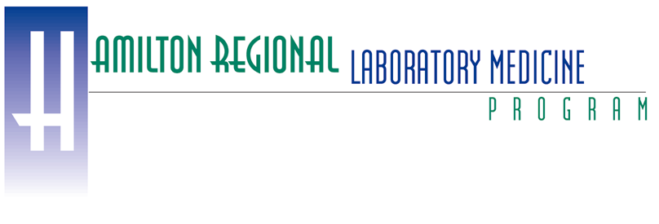
URINE PURINES AND PYRIMIDINES (UPP) - REFERENCE INTERVALS (RI)

Crystaluria | <2y |  | ≥2y to | ≤18y | >18y |  | unspecified age
 | RI limit |  | RI limit |  | RI limit |  | RI limit
 |  | umol/L |  | umol/L |  | umol/L |  | umol/L
Analyte (concentration) | lower | upper | lower | upper | lower | upper | lower | upper
Orotic acid | 1 | 9 | 1 | 13 | 1 | 17 | 1 | 14
Uric acid | 283 | 2583 | 177 | 3511 | 177 | 3511 | 200 | 3391
Xanthine | 5 | 119 | 5 | 119 | 13 | 62 | 5 | 116
Purines | <2y |  | ≥2y to | ≤18y | >18y |  | unspecified age
 | RI limit |  | RI limit |  | RI limit |  | RI limit
 | mmol/mol creatinine |  | mmol/mol creatinine |  | mmol/mol creatinine |  | mmol/mol creatinine
Analyte/creatinine ratio | lower | upper | lower | upper | lower | upper | lower | upper
Adenine /Cr | 0.2 | 10.1 | 0.0 | 9.9 | 0.0 | 3.2 | 0.0 | 10.2
Adenosine /Cr | 0.0 | 1.2 | 0.0 | 0.7 | 0.0 | 0.3 | 0.0 | 0.7
Succinyladenosine /Cr | 2.4 | 6.1 | 0.4 | 3.0 | 0.4 | 1.5 | 0.4 | 4.8
Deoxyadenosine /Cr | 0.00 | 0.00 | 0.00 | 0.02 | 0.00 | 0.01 | 0.00 | 0.02
Deoxyguanosine /Cr | 0.00 | 0.42 | 0.00 | 0.00 | 0.00 | 0.02 | 0.00 | 0.29
Deoxyinosine /Cr | 0.00 | 0.40 | 0.00 | 0.01 | 0.00 | 0.00 | 0.00 | 0.06
Guanine /Cr | 0.1 | 5.9 | 0.0 | 4.6 | 0.0 | 0.4 | 0.0 | 6.0
Guanosine /Cr | 0.04 | 2.08 | 0.00 | 0.45 | 0.00 | 0.20 | 0.00 | 1.79
Hypoxanthine /Cr | 3 | 39 | 3 | 39 | 1 | 13 | 2 | 38
Inosine /Cr | 0.3 | 5.2 | 0.2 | 2.0 | 0.0 | 1.1 | 0.0 | 4.6
Uric Acid /Cr | 166 | 1222 | 41 | 994 | 93 | 313 | 56 | 1179
Xanthine /Cr | 11 | 42 | 2 | 34 | 2 | 12 | 2 | 35
Pyrimidines | <2y |  | ≥2y to | ≤18y | >18y |  | unspecified age
 | RI limit |  | RI limit |  | RI limit |  | RI limit
 | mmol/mol creatinine |  | mmol/mol creatinine |  | mmol/mol creatinine |  | mmol/mol creatinine
Analyte/creatinine ratio | lower | upper | lower | upper | lower | upper | lower | upper
5-hydroxymethyl-uracil /Cr | 0.00 | 0.25 | 0.00 | 0.02 | 0.00 | 0.16 | 0.00 | 0.16
Deoxyuridine /Cr | 0.00 | 0.30 | 0.00 | 0.00 | 0.00 | 0.00 | 0.00 | 0.00
Dihydrothymine /Cr | 0.3 | 6.8 | 0.0 | 1.7 | 0.0 | 0.4 | 0.0 | 5.7
Dihydrouracil /Cr | 0 | 18 | 0 | 6 | 0 | 2 | 0 | 15
N-carbamoyl-beta-alanine /Cr | 6 | 36 | 2 | 23 | 2 | 11 | 2 | 31
Orotic acid /Cr | 1.0 | 3.0 | 0.3 | 2.9 | 0.3 | 1.4 | 0.3 | 2.9
Orotidine /Cr | 1.1 | 5.1 | 0.2 | 2.4 | 0.4 | 1.7 | 0.3 | 4.5
Pseudouridine /Cr | 46 | 197 | 16 | 108 | 17 | 31 | 16 | 170
Thymidine /Cr | 0.0 | 1.0 | 0.0 | 0.1 | 0.0 | 0.0 | 0.0 | 0.3
Thymine /Cr | 0.3 | 1.1 | 0.1 | 1.1 | 0.1 | 0.2 | 0.1 | 1.2
Uracil /Cr | 1 | 32 | 1 | 32 | 1 | 7 | 1 | 31
Uridine /Cr | 0.5 | 3.5 | 0.0 | 2.3 | 0.0 | 1.0 | 0.0 | 3.4

